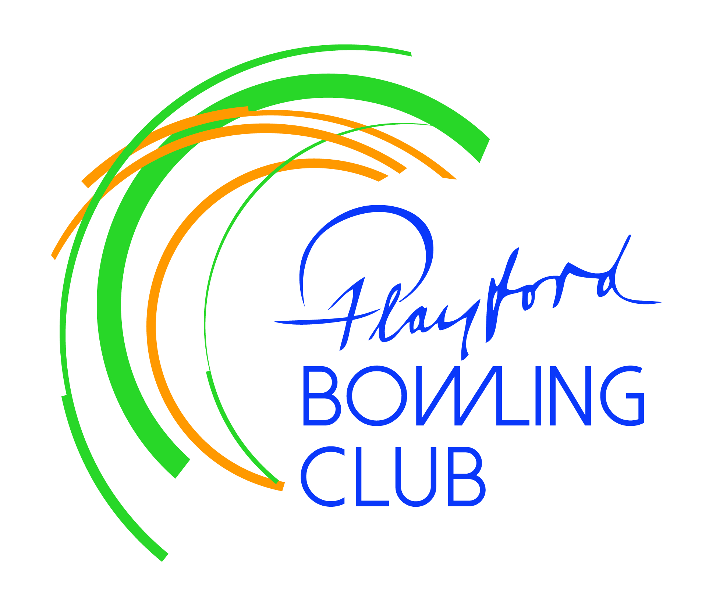
Playford Bowling Club Inc.
PO Box 34 Elizabeth SA 5112

January Newsletter

President’s Report

Happy New Year to all members – hope you had a safe, relaxing and enjoyable festive season.
Let’s now turn our attention to the second half of the pennant season with renewed enthusiasm and get as many sides into the finals as possible.

Those who came to the Christmas party had an enjoyable lunch and afternoon. We were grateful to our patron Marilyn Baker and her hubby Gary for their attendance. Marilyn supports so many clubs and community groups one way or another that her diary must be crazy in the lead up to Christmas, but she always joins us for our final function each year. We had a fantastic response from members to our request for donated Christmas gifts, and special thanks to Andy and Marian for spending many hours purchasing and wrapping an extra $300 worth of gifts funded by money in our big donations tin. Marilyn arranged collection of the gifts and their distribution to children in less fortunate circumstances.

Bowls SA have advised that Associate members can be upgraded to Full members for the remainder of the season at no charge – they have waived the capitation fee. This will remove the
“3 game restriction” and greatly assist with the filling of all 5 Saturday teams. The board has reduced the membership fees for any new members applying from Jan 1st.

Steve Attridge

Recent facility outlays

Late last year we purchased ten sets of smaller bowls to support our Junior Bowls programme. By buying in bulk and having the sets stamped with the club name we were able to reduce the cost to $5900. Many thanks to Dean Huntley and his coaching team for this initiative, which will hopefully bring new participants to the sport and perhaps to our club in due course.

Unfortunately the bar refrigeration unit developed a gas leak which could not be located and so the unit had to be replaced over the break (awaiting invoice). We also used the break to
install two drink fountains (cost $4100), which will save the ongoing cost and hassle of continually purchasing and storing replacement containers. We also installed three fans outside the bar area to assist air circulation on hot days (cost $1625).

Working bee

One of the things that I’m proudest about is the fantastic volunteer culture within our club.
That more than 20 members would turn out in the middle of the festive season to help at a working bee to spruce up the club for the second half of the season was awesome. Special thanks to Ron Slager for organizing the various tasks. Thanks to:

Andy Crawford, Steve Attridge, Mardi Johnston, Tony Johnston, Sherryll Kendall, Doug Kendall, Ann-Marie Eckert, Craig Eckert, Terry Bettens, Andy Thompson, Trevor Matthews, Ron Slager, Peter Coombs, Lyn Ruddock, Gary Wilson, Eddie Wilson, Robin Mason, Neil Jones, Brenton Ruciack, Peter DeBlaauw, Terry Coles, Chris Butler.

Miscellaneous

On the day of the working bee there were 6 bowls bags, 5 pairs of shoes, 4 bowling arms, 4 hats and 3 lifters in the men’s change-room. Will the owners please store these in a locker or take them home by the end of the month, at which time they will be placed in a box in the shed.

Keep an eye on the cut-off date for each round of the various club championships. The club will be open for the next two Sunday afternoons (Jan 18 & 25) to ensure each round is completed on time. Please remember to “book” a rink by entering your match on the whiteboard by the bar – you cannot just turn up and assume there will be space.

On Sunday afternoon (Feb 1st) the club will hold a “Thank You” event for our sponsors, giving them an opportunity to try our sport. Club members are invited to come along as well – BBQ food will be available.

In that context, welcome to Roof Rescue who have come on board as a new club sponsor. If you have any roof issues contact Darren Chammings on 0417 444 182.

This year’s Prestige Medley finals will be held on the south coast - the women’s at Encounter Bay BC and the men’s at Victor Harbor BC – on the weekend of March 28 & 29. Twelve regional teams will take part and anyone wishing to be considered for selection should refer to the poster on the office noticeboard.

Sales of Coopers Pale Ale on tap were disappointing and so this product has been replaced by Playford Draught, which (under another name) is the top-seller at Prospect-Broadview BC.
Early response has been encouraging.

